First person vs third person
A prototype was made where both first person and third person were implemented. The team members immediately preferred first person over third person. The player feels more like they are the character they control. It allows for more accurate controls, especially regarding interacting and platforming, the two main concepts of the game.

Setting
In the initial brainstorm session, a lot of mechanics came up, which the team members were very excited about. Since the mechanics differed a lot, with a different setting for each mechanic. E.g., rope swinging in a jungle setting or different gravity in a space setting, the team decided to use several of the mechanics for the game. To justify this, the game’s overall setting is an alien scientific facility with test chambers to test their advanced technology. As the aliens are experimenting the technology in different environments, the settings from the brainstorm are suitable for the game.

Level structure
The player must be focused on the puzzle of the room, without confusion as to how the room is structured. The decision was made to have one single entry door and one single exit door. As the structure of the testing chambers is not part of the puzzle (in some games there are exceptions to this), it is beneficial for the player that the testing chambers show consistency.

Intro story
There have been made several stories justifying why the scout is sent to the alien scientific facility and how the tutorial is made.
One story started with the aliens giving the humans a gift in the form of a test room: the tutorial. The humans decide to spy on the aliens and send the scout. This idea was discarded as it contradicted the morality of the designers.
A second idea included the alien spaceship to have had an accident, where part of the spaceship broke off and landed on Earth. The humans used this as a preparation area to send the scout to the facility to learn. This idea was discarded as it would require more backstory.
The final idea is that the alien spaceship randomly appeared one day. The humans scanned the spaceship which revealed common objects in rooms in the ship, which are used to create a preparation area. The scout is sent to the facility to learn. As this was the simplest idea to tell the player, the team chose to use this story.

Player model
When thinking about picking up objects and looking straight down, the question was raised about whether a player model is required. In Portal 2, the player ‘holds’ the objects with the portal gun, removing the necessity to have a player model. In The Scout, the player does not have a tool to hold objects. When looking straight down, the player can expect to see their own body too. With these two reasons in mind, the decision was made to create a player model.

Tutorial
In the first feedback session of the development, where the first level, the tutorial, was shown, the team got the feedback that the tutorial was too simple for players who played with similar mechanics before. There were two ideas that came up to improve the tutorial.
- Adding more complex puzzles and increasing the learning slope of the tutorial, so the player is presented more difficult puzzles sooner.
- Giving the player the option to skip the tutorial completely.
The decision was quickly made to go with the first option.

Singleton implementation
Throughout the development of the game, the team needed references to single objects a lot of the time. To make this easier, the team decided to create a singleton.
A first implementation was made where all singletons where stored as a reference in one class:
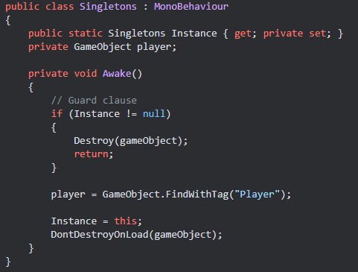
As this was not the most ideal solution regarding the SOLID principles, as every singleton needs to be added to this class, a team member came with a solution from an older project:
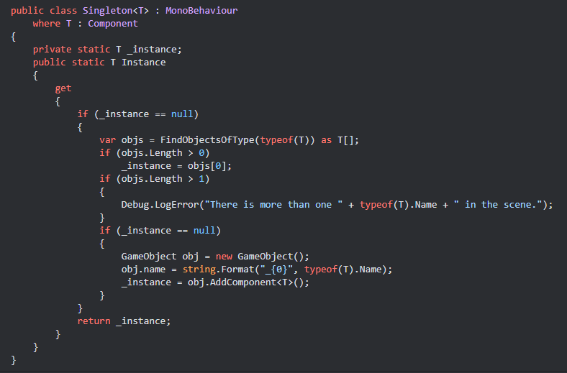

Copying blueprints
The player is sent to the spaceship to learn as much as they can about the aliens. On the spaceship, the player encounters unique technology and the blueprints for them, so the player needs a way to communicate the information back to the base on Earth.
The idea of having video communication with Earth could be an easy way to communicate the blueprints to Earth. An added effect is that storytelling could be easier, as the base can see what is happening instead of the requirement of the player having to communicate everything through speech. This idea however was discarded quickly.
The player could use a USB to copy digital blueprints. The issue with this idea was that there is no reason for the aliens to have the same mechanical properties for their technology, in this case USB ports.
The team chose for the player to copy the blueprints manually, by drawing them out with pen and paper.

Gravity mechanic music
The game makes use of adaptive music, where the mechanics each have a different influence on the music. The idea behind the behind the music of the mechanics is that it changes based on the state of the level. For the electricity level, the music changes when a circuit is powered. For the gravity mechanic, the original plan was to change the music based on the direction of the gravity. The initial idea which would be the most diverse, therefore noticeable, would be to mute / unmute different instruments based on the direction. As the gravity can go in six different directions (up, down, forward, backward, left, and right).

Levels to implement
In the first sprint meeting, much feedback was received, with much enthusiasm for the illusion level. As a result, and because of time constraints, the team decided to create the tutorial and the illusion level. The tutorial has elements which are used in every level of the game, making it an excellent candidate to implement, as it will not take much time compared to the gravity and electricity level.

